General relativity

From Wikipedia, the free encyclopedia
(Redirected from General theory of relativity)
For the book by Robert Wald, see General Relativity (book).
For a more accessible and less technical introduction to this topic, see Introduction to general relativity.
General relativity
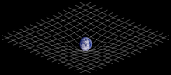
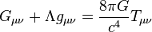
  - Introduction
  - History
- Mathematical formulation
  - Resources
  - Tests
Fundamental concepts[show]
Phenomena[show]
- Equations
- Formalisms
[show]
Solutions[show]
Scientists[show]
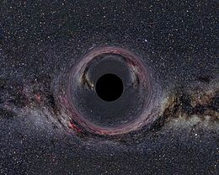
A simulated black hole of 10 solar masses within the Milky Way, seen from a distance of 600 kilometers.
General relativity, also known as the general theory of relativity, is the geometric theory of gravitation published by Albert Einstein in 1915[1] and the current description of gravitation in modern physics. General relativity generalizes special relativity and Newton's law of universal gravitation, providing a unified description of gravity as a geometric property of space and time, or spacetime. In particular, the curvature of spacetime is directly related to the energy and momentum of whatever matter and radiation are present. The relation is specified by the Einstein field equations, a system of partial differential equations.
Some predictions of general relativity differ significantly from those of classical physics, especially concerning the passage of time, the geometry of space, the motion of bodies in free fall, and the propagation of light. Examples of such differences include gravitational time dilation, gravitational lensing, the gravitational redshift of light, and the gravitational time delay. The predictions of general relativity have been confirmed in all observations and experiments to date. Although general relativity is not the only relativistic theory of gravity, it is the simplest theory that is consistent with experimental data. However, unanswered questions remain, the most fundamental being how general relativity can be reconciled with the laws of quantum physics to produce a complete and self-consistent theory of quantum gravity.
Einstein's theory has important astrophysical implications. For example, it implies the existence of black holes—regions of space in which space and time are distorted in such a way that nothing, not even light, can escape—as an end-state for massive stars. There is ample evidence that the intense radiation emitted by certain kinds of astronomical objects is due to black holes; for example, microquasars and active galactic nuclei result from the presence of stellar black holes and black holes of a much more massive type, respectively. The bending of light by gravity can lead to the phenomenon of gravitational lensing, in which multiple images of the same distant astronomical object are visible in the sky. General relativity also predicts the existence of gravitational waves, which have since been observed indirectly; a direct measurement is the aim of projects such as LIGO and NASA/ESA Laser Interferometer Space Antenna and various pulsar timing arrays. In addition, general relativity is the basis of current cosmological models of a consistently expanding universe.

